**Harrow Borough Based Partnership**

**Borough Partnership Plan and 202/23 Delivery Framework**

**DRAFT v4.0 – July 2022**

***“Working with children, families and communities in Harrow to support better care and healthier lives”***

**Harrow Borough Based Partnership**

**Borough Partnership Plan and 2022/23 Delivery framework**

1. **Introduction**

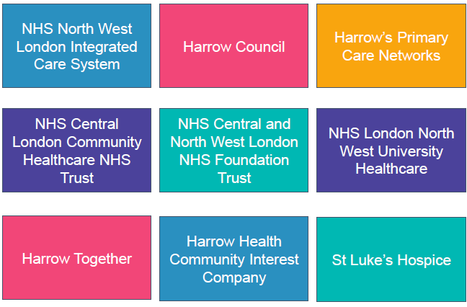

Harrow Borough Based Partnership brings together our NHS organisations, Harrow Council, our GPs, and local Voluntary & Community Sector. We strive to support each other and our communities as equal partners focussing on better health and wellbeing for all.

The partnership has agreed their mission as:

**“Working with children, families and communities in Harrow to support better care and healthier lives”.**

The Harrow Borough Based Partnership operates within the Integrated Care System for North West London and works to both support delivery of the wider system objectives. We do this alongside being clear about the needs of Harrow; what is unique about our borough, what the health needs of our population are and how as a local partnership, we become the engine room for delivery and service reform for Harrow citizens.

Current Legislation that will come in from 1st July 2022 will create new integrated care arrangements for health and care services in England. This cements the long-standing vision for integration that we have had in Harrow and provides a unique opportunity to accelerate how they are adopted for everyone; joining up services, focusing on the needs of individuals and their families. We will seek to build new connections with communities in Harrow; listen more to people about what is important to them and modify or develop new services and improve pathways in response to the feedback. We will strengthen our approach to preventative services, in partnership with our voluntary and community sector, to support our population stay well and support wellbeing, both physically and mentally, ensuring fair access for all and reducing the inequalities that we currently see in health outcomes.

Driven by Harrow’s Health and Wellbeing Strategy, this document sets out the three-year plan for the partnership and our delivery framework for 2022/23.

* 1. **The journey of our partnership to date**

**Progress from the first 100-day Plan (Summer 2020)**

* Initial partnership governance, leadership and financial arrangements
* Three meta-risks identified and managed: subsidiarity, finances and resources
* Transformation and enabler workstreams established
* Priority areas of work identified for each.
* SROs and management leads identified
* Progress on improving collaboration and outcomes (e.g. joint SRO roles, VCS partner funding)

**Progress from the second 100-day Plan (Summer 2021)**

* Engagement with front-line teams through the ‘Harrow Conversations’.
* Established an Integration Operational Leads workstream.
* Established a Primary and Secondary Care Interface Group.
* Invested in an intensive programme building integrated frailty teams at a PCN / neighbourhood level.
* Additional winter investment made in primary care, social care and community health services.
* Development of plans to integrate our training and development programmes.
* Progress towards full integration of reablement and intermediate care services in Harrow.
* Taking action to address inequalities working with Voluntary Action Harrow.
* Recruited an analyst to build outcome and impact dashboards for each transformation workstreams.
* Commenced local system oversight to hold ourselves and each other to account.
* Implemented the refreshed borough-based partnership governance including new Clinical Senate.

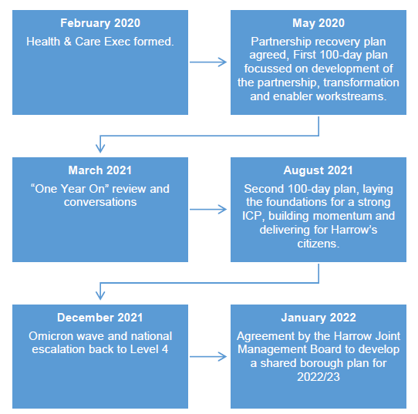

**1.2 Why do we need a Borough plan now?**

To-date, there have been a number of short to medium term “sprints” for the Harrow Health and Care Partnership to accelerate our development and set us up for success. Much has been achieved through this approach but the time is now right to set a longer-term view for the partnership, defining what we are seeking to achieve through a strategic planning process and how through a one-year delivery plan.

We have confirmed the importance of the partnership over this period, and the importance of our collective response to the most challenging issues we face. Legislative changes in the health and care landscape that will now come in from 1st July 2022 will set a new policy landscape, alongside the development of a strategy for the Integrated Care System in North West London. In addition, and as partnership, our attention also now is increasingly focusing on system financial controls, managing demand and addressing workforce challenges across all providers.

A plan cannot be delivered in isolation and must build and deliver for the Harrow Health and Wellbeing Strategy well as strategy and operational plans of organisations in the partnership.

The success criteria of such a plan though would be that it is owned and valued by all members of the partnership (including our Primary Care Networks, Local Authority, Harrow Together, CLCH, LNWHT, CNWL, Harrow Health, St Luke’s and the Borough team of the ICS), and our local communities, reflecting what is important to them, relevant to the priorities they have for their health and wellbeing, with addressing health inequalities at its core.

1. **Building our plan**

As a partnership we have used the following four questions as the foundation for our plan:

What are the needs of the Harrow population, how do we understand them and respond to them?

What will we be able to achieve as a partnership that we cannot achieve as individual organisations?

How are we currently performing as a system in relation to performance, outcomes, quality and finances?

What does the future integrated health and care system look like and what will the role of Borough Based Partnerships be within it?

Our key findings and how these have influenced the plan, our mission and our priorities are as follows.

**2.1 What are the needs of the Harrow population, how do we understand them and respond to them**

Understand the needs of our population is a live and active process. As a partnership, we will achieve this through listening and engaging with our communities in Harrow, ensuring that our conversations and reach is to all of Harrow’s communities. **Working closely with communities, community groups and partners** has been critical to addressing the challenges posed by the pandemic. A coordinated approach to engaging communities through joint working has enabled production of local resources, and greater impact and reach on the ground. The impetus given to tackling inequalities by the Black Lives Matter movement has also strengthened our work with communities of Black heritage. Bringing groups together on a single platform, we held two meetings with Black heritage community leaders in 2021, with the latter one giving a significant focus on improving health inequalities, linking in with the priority to address health and social care inequality. As a result of this dialogue the council and local NHS are currently investing £150k to commission ongoing engagement with these communities to reduce health inequalities.

Some challengescontinue to remain, in some cases have worsened, and other cases are new challenges that have evolved over the last couple of years.

The pandemic has shone a light on inequalities and highlighted that much work needs to be done with some communities that are experiencing disparity in social, economic and health outcomes, such as the Romanian population which lags behind in access to health services. Through the efforts during the pandemic, we have been able to map and identify communities that we need to reach better. This conversation and engagement must continue to ensure that communities and residents are at the heart of addressing and tackling these inequalities.

Harrow is one of the most ethnically and religiously diverse boroughs in the country with people of many different backgrounds and life experiences living side by side. However, the partnership can do more to enhance the lived experience and better outcomes for all residents.

The partnership recently heard clearly from children and young people through the ***HAY Harrow Survey*** about some of the issues they are faced regarding emotional health and wellbeing. Most said that they feel loved and supported which is testament to the wonderful families, schools and colleges in our Borough. However, some young people raised concerns around their emotions - feeling down or anxious, some young people feel unsafe in Harrow, and some groups of young people are really struggling. The survey found that young people who identify as non-binary or Chinese find life especially hard with regards to bullying, safety and life satisfaction. The survey also highlighted several areas around violence, gangs, online safety, and the ability to be assertive in relationships.

Messages we have heard are:

* Harrow Council held a meeting with black community leaders in Harrow to address the inequalities among Harrow’s black residents. Some of the feedback from the meeting were – black community leaders felt ignored by the current system and did not feel that they were a priority. They felt the system always assumed what the black communities needed instead of engaging with them actually to understand what the community needs.
* We heard from our Romanian community about dissatisfaction with what they felt was a telephone/digital-first approach to GP consultations. They don't feel confident with their English for e-consultations or speaking over the phone.
* Harrow Citizen Forum was launched on the 15th of March 2022. Several attendees' concerns were access to primary care, medical appointments, and elective procedures.

Key themes from our conversations with our communities to date are summarised in Appendix A and our engagement is ongoing as we build trust and confidence in health and care services in Harrow.

**The Harrow Joint Strategic Needs Assessment** has been refreshed post-pandemic, to ensure that it remains up-to-date and relevant in identifying the current needs of our richly diverse population. The table below summarises the headline findings of the assessment:

*Population health needs: the headline findings from the Joint Strategic Needs Assessment.*

|  |  |  |  |
| --- | --- | --- | --- |
| **Start Well** | **Live Well** | **Work Well** | **Age Well** |
| Increasing trends in births noted over the last 10 years & fertility rates in Harrow remain higher than the London and national averages  Under 19s reflect increasing ethnic diversity in Harrow with the largest group belonging to Asian Indian population.  Infant mortality on downward trend, and Harrow currently has the same rate as England 3.9 per 1,000 live births  GCSE and School readiness remain higher than the regional and London averages in Harrow  Pupils with Special Educational Needs increased for the 5th consecutive year  Prevalence of obesity amongst 10–11-year-olds twice as high as those ages 4-5, 21% compared to 9.5% on 2019  Estimated 4861 children and young people between the ages of 5 to 17 with a mental health disorder in Harrow  Highest proportion of children aged 5 with tooth decay, rising from 39.6% in 2017 to 42.4% in 2019 and continues to rise, almost double national trends | Half of all adults in Harrow are not meeting minimum required level of physical activity guidelines set by Chief Medical Officer (CMO), and only around 57.2% of adults are active  58.5% Harrow adults are either overweight or obese  Harrow ranked 26th highest out of 149 upper tier and unitary authorities for new STI diagnoses excluding chlamydia among young people aged 15 to 24 years in 2020, with a rate of 774 per 100,000 residents aged 15 to 64  Over 35,000 people in Harrow diagnosed with hypertension; 6,669 / 19% of those people are poorly controlled  10.1% of patient overs 17 on GP registers have diabetes, and 13.4% have hypertension*  Smoking prevalence in adults with a long-term mental health condition in Harrow is 20.6%, nearly double the general smoking prevalence, and rates of smoking in the most deprived decile is 24%  The under 75 years mortality rate from cancer is higher amongst women than it is for men in Harrow | Unemployment in Harrow is overall low 5.9%, however there are areas within the borough with higher rates of unemployment  16–17-year-olds not in work or education (NEET) are around 2.6% which has increased in the last year; London rates are 4%  Gap in the employment rate between those with a learning disability and the overall employment rate - 67%; on a par with London and nationally  Gap in the employment rate for those in contact with secondary mental health services and the overall employment rate – 59%; best in London | Harrow has one of the highest proportions of those aged 65 and over amongst its neighbouring boroughs, at 16.1%, higher than London at 12.2%.  In the future, there is a further projected increase in those over the age of 65 in Harrow with an overall increase of around 22% by 2025  Both male (82.2) and female (85.7) life expectancy has seen a decline due to COVID in 2020 in line with national trends but in Harrow remain higher than the regional and national averages.  The rate of emergency hospital admissions due to falls in people over 65 is 2,380 per 100,000, significantly higher than London and England.  Recorded prevalence of dementia in people aged 65 and over is 3.93%, in line with London and national averages.  Carer-reported quality of life score for people caring for someone with dementia – worse compared to similar Local Authorities.  Patients in need of palliative care/support, as recorded on practice disease registers, irrespective of age – 0.2%, significantly lower than London and England. |

The intelligence, through conversations with our communities and public health data has been central to the development of this plan and will remain central to how we deliver and update it.

**2.2 What will we be able to achieve as a partnership that we cannot achieve as individual organisations?**

The Harrow Borough Based Partnership is a collaborative partnership, comprised of individual organisations serving the health and care needs of Harrow citizens, and those taking action to address the wider determinants of ill health. This plan can only have impact and be meaningful where delivery of it **together as a partnership** will drive greater success and better meet the needs of our local communities. To ensure this is the case, as a partnership we have held discussions across member organisations to capture their priorities. These are attached in Appendix B.

The recognised overarching shared challenge across our partnership is workforce, in relation to current capacity, retaining our workforce and planning ahead for the future. There is strong agreement that this should be an area of collective focus so that we harness efforts, rather than compete for clinical and non-clinical roles. Our partners all have ambitions to work with our communities in new ways, to reach people not currently accessing health services, to support access to care and to reduce the variations in outcomes that we currently see. This has translated through into our delivery plan on action to address health inequalities and support greater levels of integration across the system.

**2.3 How are we currently performing as a system in relation to performance, outcomes, quality and finances?**

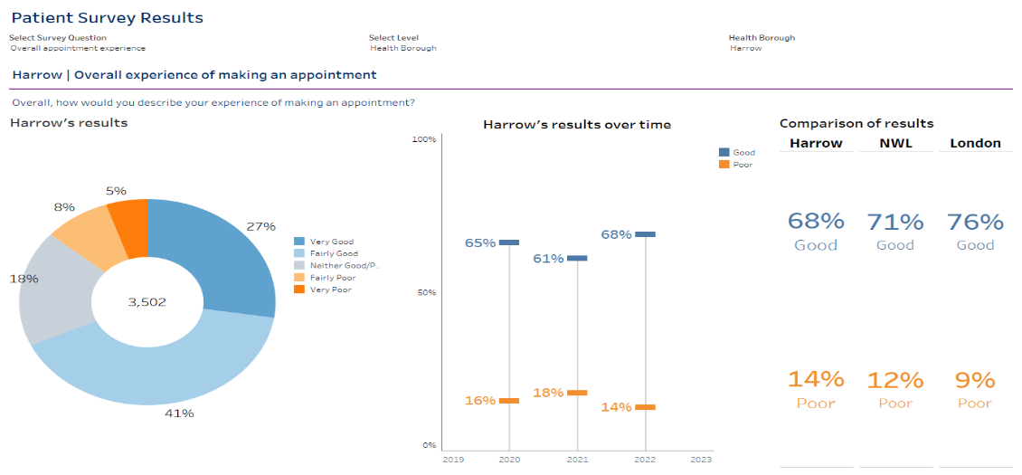In addition to its long-term goals for improving the health of the population the Borough Based Partnership is developing the measures that it will use to monitor changes in population health and the use, experience and impact of health and care services. The following are likely to be refined over time but are intended to give some indication of the current performance of the health and care system. Detail charts showing performance measures are attached as Appendix B.

***Access to General Practice***

The GP Practice Patient Survey results below indicate a significant recent improvement in patient satisfaction with access and the process for making appointments, although this remains lower than for NWL and nationally (*figure 1*). Fewer Harrow patients attend A&E than the average across North West London.

***Diabetes: 9 Key Care Processes Achieved in Last 15 Months***

Harrow performs poorly (23%) against the NWL average (36%). The variation in performance between NWL PCNs is very high: almost a quarter of PCNs achieve > 50% while a third are < 30%. The performance of all of Harrow’s PCNs is in the bottom half of NWL PCNs, with performance ranging from 35-13%.

Figure 1: Patient survey results

The BBP is developing an integrated diabetes care model for the borough that will use substantial additional resources to work with patents to prevent patients from becoming diabetic and support those who are diagnosed to reduce complications and maximise health outcomes. We would also be working with individual PCNs and system partners to improve on these targets over the next financial year.

***Vaccinations in Harrow***

Rates of influenza vaccinations in Harrow were 25% higher than in NWL as a whole. Harrow has also had one of the best uptake levels of COVID vaccination across all ages and in care home settings, in North West London. [placeholder: include childhood immunisation uptake].

***Cancer Screening in Harrow***

Screening rates for cervical cancer are slightly lower in Harrow (49%) than across NWL (51%). We had introduced weekend cervical cancer screening clinics but the uptake had been low. Although breast cancer screening rates are higher in Harrow (54%) than NWL (43%) there is very wide variation with some practices having rates of < 15%. Bowel cancer screening rates are 97% in Harrow compared to 96% across NWL.

***Non-Elective Admissions***

The BBP will, in future, monitor the non-elective admission of patients with ‘Ambulatory Care Sensitive Conditions’ i.e. those long term conditions that can, with self-care supported by primary and community services, be managed so as to avoid the need for unplanned (non-elective) hospital admissions. Unplanned / non-elective admission rates by weighted population are significantly higher in Harrow than the NWL average.

***Children Under Five Years Old with Tooth Decay***

The Borough Based Partnership is proposing to use the proportion of children under 5 with tooth decay as an indicator of engagement of dietary habits and the engagement of families with health services. The incidence of dental decay among under-fives in Harrow (42.4%) is the worst in London (Average 27%) and 57% higher than the national average (23.4%).

**Finance**

All partners within our Borough Based Partnership are experiencing increased demand for services against a backdrop of workforce shortages and an increasingly challenging financial picture. Greater integration and collaboration can support the work of all organisations within this context. Developing strong, integrated teams in Harrow’s neighbourhoods will better support our citizens to be care for in a community setting, reducing higher cost unplanned care and intensive social care packages. This will mean using our workforce in new ways, to support this as a care model, making every contact count, increasing efficiency, and reducing duplication through collaboration. As a partnership, we know that we will not see significant additional investment into our system over coming years, and therefore we need to commit to spending the Harrow pound in the most effective and efficient way for our citizens through prevention, early intervention and community based care.

**2.4 What does the future integrated health and care system look like and what will the role of Borough Based Partnership be within it?**

The Harrow Borough Based Partnership operates as part and within the North West London Integrated Care System. A new Health and Social Care Bill will come into effect in July 2022. The Bill will allow for the establishment of Integrated Care Boards and Integrated Care Partnerships across England. This will be done at the same time as abolishing Clinical Commissioning Groups (CCGs). These new arrangements will formalise arrangements that are already being adopted across most of the country. They are being made to deliver more joined-up care. Every part of England will be covered by an integrated care system (ICS) bringing together NHS, local government and wider system partners to put collaboration and partnership at the heart of healthcare planning.

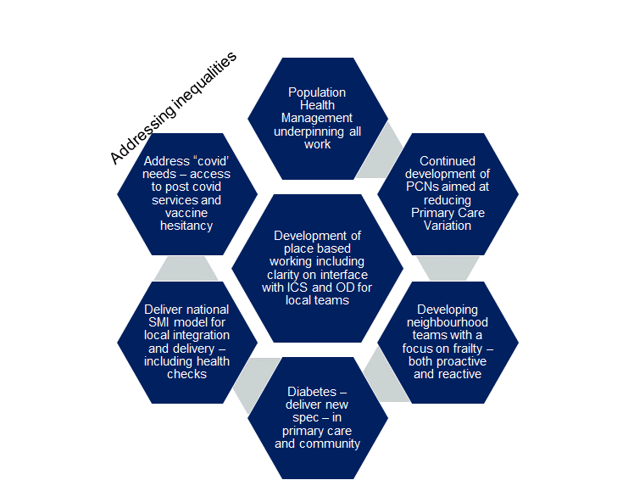Arrangements for how services are planned, delivered, and evaluated are currently being established. The landscape will involve the ICS at a North West London level, Provider Collaboratives (currently in North West London for hospital care, community based care and mental health care) and Borough Based Partnership. Each of these forms of collaborative arrangements offer new and innovative ways to deliver high quality care and ensure financial sustainability of the system.

As a Borough Partnership, we will secure our place in these new arrangements, aligned to the principles set out in the Health and Social Care Integration paper; to strengthen the health and care services in places that feel familiar to the people living in them. While strategic, at-scale planning is carried out at the integrated care system, places, such as Harrow, will be the engine for delivery and reform. As Borough Based Partnership, we are excited about this unique opportunity to transform care and recognise the responsibilities we need to deliver for a new system vision.

We have committed as a local partnership to deliver the six ICS objectives for local partnerships (*figure 2*).

**2.5 Conclusions and implications for the Borough Plan**

The population of Harrow overall enjoys good health and wellbeing, but we have real and important challenges that we need to address; and which we believe we can do best together*.* These challenges are across preventative services, access to services and in ensuring best outcomes from services. There is an overarching theme in the assessment of our current position to work more closely with our communities to really understand what people need to support them to stay well and access our services when they need to in order to address the health inequalities that we see. We need to look at where are challenges are now and where they will be in the future, with an increasing birth rate, increasing levels of obesity and the high prevalence of diabetes in our borough. This is what has shaped the mission and priorities for the partnership in the coming years.

Figure 2 ICS objectives for Borough Based Partnerships

1. **The Harrow Borough Based Partnership Strategy: Mission and Priorities**

|  |  |  |  |
| --- | --- | --- | --- |
| **Our mission: Working with children, families, and communities in Harrow to support better care and healthier lives** | | | |
| **Our objectives** | 1.  Reduce health inequalities through embedding a robust population health management approach at a borough and neighbourhood level | 2.  Developing truly integrated out of hospital teams at a neighbourhood level to improve our citizens experience of care and reduce unplanned acute care and intensive social care packages | 3.  Deliver transformational change in care pathways to deliver high quality integrated care, improving outcomes and addressing variation |
| **Core work programme** | * Set our Harrow Population Health Management methodology and implement at borough and neighbourhood level * Aligning data and intelligence across partnership organisations * Delivery of core 20 plus 5 programme | * Digital integration * Estates development as an enabler for integration * Integrating our training and education offer across the partnership * Strengthening our support to carers * Supporting the development of Harrow’s Primary Care Networks | * Frailty through implementation of the integrated frailty model for Harrow * Long term conditions care, with specific focus on diabetes care and hypertension * Mental Health and learning disability services transformation * End of life care: strengthening integration and ensuring a choice of where to die for Harrow citizens |
| **Delivery priorities for 2022/23** | * Establish a community capacity building and leadership programme for Harrow to support community groups access to help them address issues which are important to them. | * Workforce development programme: * In the long term by promoting, as a partnership, Harrow as a place to live and work * In the short to medium term, better engagement and problem solving with our front-line teams to support retention and best use of our resources | * Deliver transformational change for our children and young people, through: * A “think family” approach across all workstreams * Strengthening the integration between health, social care and schools * Integrated physical and mental health services, across primary and secondary care, aligned at a neighbourhood level |

The mission of our partnership; *Working with children, families, and communities in Harrow to support better care and healthier lives*, will be central to our collective action as a partnership and what drives our priorities and investment. Ultimately, this is about understanding our citizens within their social context and consider people’s families in the broadest sense; the people who are their support network, including people who care for them. We will look at how are preventative services work with people in different ways considering this, and when they interact with the health and care system, we seek to understand these important factors in their lives and how we both work with and adjust our approaches in light these networks as part of the support we are providing.

* 1. **Objective one: Reduce health inequalities through embedding a robust population health management approach at a borough and neighbourhood level**

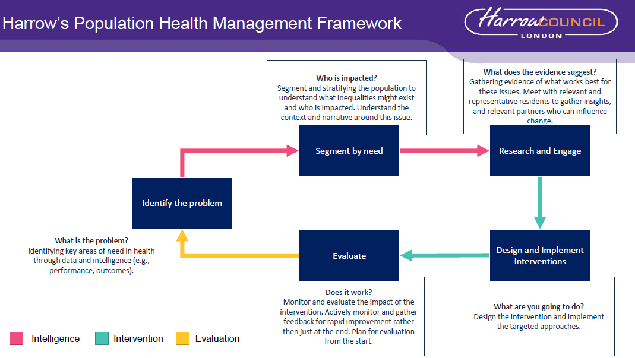

Understanding and addressing health inequalities is the central role of the Borough Based Partnership. We are uniquely placed as a Borough Based Partnership to build a deep understanding of the needs of the population of Harrow as a whole, and at a neighbourhood level through our primary care networks, to use the data and community intelligence to deliver a more robust preventative service offer, improve access to care and address variations in outcomes from care that we see in Harrow.

Population health management is an approach being adopted across North West London and empowers partnership working and community engagement, to deliver care that will improve the health and wellbeing of our citizens. It is about using the intelligence that we have as organisations across the partnership to commit to shared understanding of need, collective action to address it and shared outcomes to measure the impact of our success. As a partnership, we have agreed a methodology for a population health management approach (*figure 3*) which has been used successfully in other North West London boroughs.

*Figure 3: Harrow’s Population Health Management Framework*

The partnership has agreed three key areas of action, which are detailed in our delivery plan to reduce health inequalities in Harrow:

* To work more closely with communities in Harrow through a community champions programme; training community based leaders in Harrow to lead discussions with Harrow citizens on issues that matter to them, and supporting the delivery of preventative initiatives that support people to stay healthy and well. This programme is aligned closely to the mission of the partnership to support children, families and communities. This is a central delivery priority in 2022/23.
* To work across the partnership to better connect data and analytical capabilities that will allow us to link and combine data to support an effective population health management approach. The North West London Whole Systems Integrated Care (WSIC) database provides much for the needed capabilities for this. Our objective is to move as a borough from having this data, to collective using this data with shared purpose and intent, in line with our population health management approach, so that the insights it gives us are used to deliver action to address health inequalities. This work will be undertaken at both a borough and neighbourhood level, through our PCNs, and the work of the partnership will be to secure the capabilities and capacity and both levels to implement this effectively.
* Delivery of the *Core 20 plus 5* programme. *Core 20 plus 5* programme is a national NHS England programme of work, designed to support Integrated Care Systems to address health inequalities. Much of the delivery of this programme of work will be through the Borough Based Partnerships in North West London. The programme focuses on 5 key areas for addressing health inequalities:
  + **Maternity:** ensuring continuity of care for 75% of women from Black, Asian and minority ethnic communities and from the most deprived groups.
  + **Severe mental illness (SMI):** ensuring annual health checks for 60% of those living with SMI (bringing SMI in line with the success seen in learning disabilities).
  + **Chronic respiratory disease**: a clear focus on Chronic Obstructive Pulmonary Disease (COPD) driving up uptake of COVID, flu and pneumonia vaccines to reduce infective exacerbations and emergency hospital admissions due to those exacerbations.
  + **Early cancer diagnosis:** 75% of cases diagnosed at stage 1 or 2 by 2028.
  + **Hypertension case-finding**: to allow for interventions to optimise blood pressure and minimise the risk of myocardial infarction and stroke

At a NWL and Harrow level we will look across our programmes with a health inequalities lens to identify if themost deprived 20% differ in terms of access, outcomes and experience and if so test and implement ways to address this. We will also use Core20 to look at key public health outcomes e.g., obesity, dental health

**Over the coming year we will:**

* Set up community conversations on a regular basis in all NW London boroughs
* Develop a targeted, data-driven and comprehensive outreach programme in each borough, working across the NHS and local councils and in partnership with the voluntary sector and Healthwatch
* Work with primary care networks to improve their approach to public and community involvement (with NHSE funding)
* Work with community groups and those with reach into local communities to broaden our understanding of our population
* Produce monthly insight reports highlighting feedback from community conversations
  1. **Developing truly integrated out of hospital teams at a neighbourhood level to improve our citizens experience of care and reduce unplanned acute care and intensive social care packages**

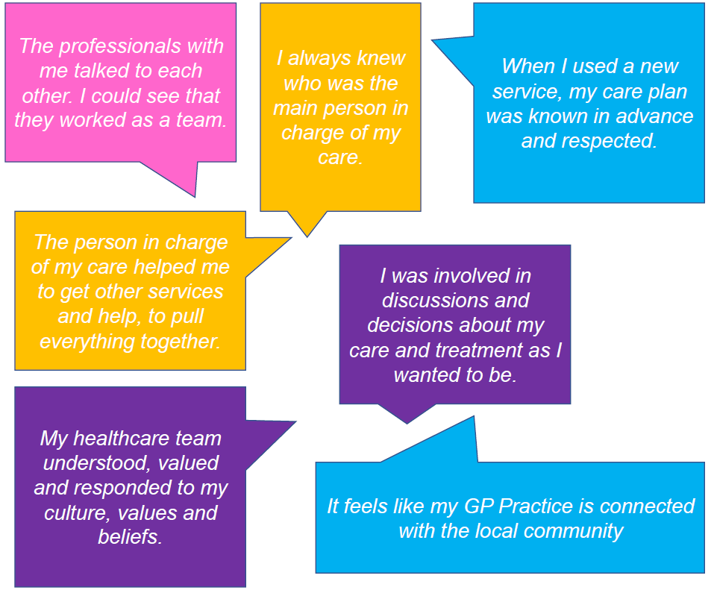We know the people of Harrow already receive, in the main, high-quality care from our existing services. We also know that people, including our staff, feel frustration by a lack of coordination of services. In addition, some parts of our communities are not using preventative and early intervention services at all, which can lead to people accessing services in an urgent situation when their needs are much more severe. We need to address the causes of why this is happening.

Through engaging with our front-line teams and citizens using our services, we have set out how we would like our services described in the future, for every person accessing our services (*figure 4*).

To achieve this, we have set out action in five areas for the partnership which will be underpinned by the development of integrated neighbourhood teams in Harrow.

**Integrated neighbourhood teams**

At the heart of our Borough Plan is the vision for integrating primary care; bringing together previously siloed teams and professionals to do things differently to improve patient care for whole populations.

*Figure 4 Our aim for how health and care services in Harrow are described*

Harrow’s Primary Care Networks are the footprint for neighbourhood-based care delivery. They provide the focal point for multi-disciplinary teams to come together to understand and meet the health and care needs of their populations. As a partnership, we are cognisant of the central importance of these networks, alongside an awareness of them being new organisations, with new leadership and the call made through the ***Fuller Stocktake Report (2022*)** for the need to evolve the current PCN forms to integrated neighbourhood “teams of teams” – primary care services fully integrated with community health and mental health services, social care and supported by the acute sector to support people in a community setting.

Harrow is committed to the move to a whole population care model for integration, through the development of our neighbourhood teams. The approach of our partnership will be to build this in incremental steps, starting with our priority pathways based on population health need and setting in place a full system response to developing the capacity and maturity within our existing PCNs. The broad outline for our development approach is as follows:

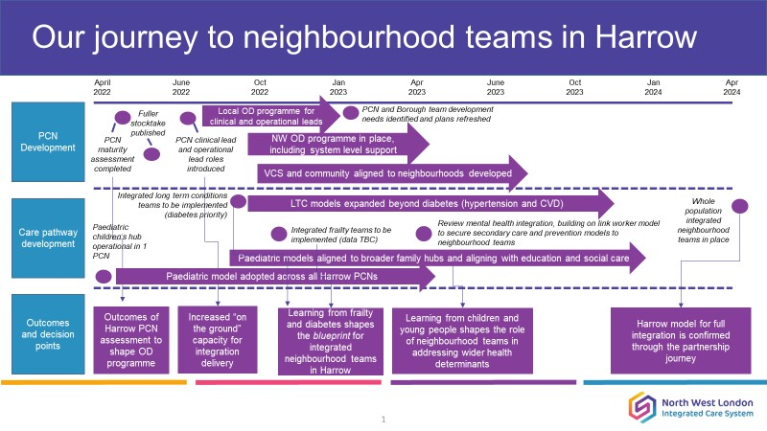

The partnership has invested in additional clinical leadership support in 2022/23 for each PCN, as well as securing resource from the NWL CCG Borough Team in terms of operational management. An organisational development programme has been invested in alongside this to set the new roles up for success. We are committed to working with the PCNs alongside operational management functions across the partnership, to support development and to adopting a proactive approach to managing population health and assessing the needs of their local population through neighbourhood integration plans

**Workforce**

Securing our workforce in the short, medium and long term is central to delivery of our ambitions. In the short terms, we will focus on retention of our existing workforce through improving their satisfaction with their roles, and for longer term action, forging partnerships with higher education institutions and employment assistance bodies in promoting careers in health and care within Harrow and championing it as a borough that is a great place to live and to work.

**Digital integration**

The ability to safely integrate our IT systems across health, social care and extending in the longer term to our voluntary and community sector delivery partnership, is central to unlocking truly integrated care. We believe as a partnership that in the longer term, this should move us away from a system of referrals across services, where care is essentially “handed-off”, often without the full information needed to one where a team of professionals work off of a shared care record to support individuals and secure the care they need meaning patients only need to tell their story once. Securing our Voluntary and Community sector within this would revolutionise pathways into the community and we would strive to work to this model.

**Estate development**

Having the right estate available in Harrow, that allow our teams across health and care to come together in the planning and delivery of support for our citizens is an essential enabler of integration. Meeting our current and future estates needs with require appropriate capacity planning as well as maximising the opportunities digital working brings to use our space more flexibility.

As our population grows, we need to make sure that we have fit for purpose buildings in place to deliver the care required. In addition, as health and care professionals come together increasingly in multi-disciplinary teams, we need them to be able to use their IT equipment and access records in locations outside of their usual working base. Our estates need to support these new ways of working.

The North West London Integrated Care System has commissioned the development of Borough Based Partnership estates plans, in each of the eight North West London Boroughs. This review will look at opportunities and any void space across partnership organisations and consider options for ensuring our estate can meet our current and future needs.

**Training and education**

Our workforce at the heart of wrapping care around individuals. Over 2021/22, the partnership has focused heavily on identifying opportunities to further integrate our training and education offer in order to bring professionals from a range of backgrounds together to learn together, make new connections and gain a greater understanding of different roles supporting individuals. Our task in 2022/23 is to implement a new integrated programme through the organisations that make up the partnership. Key priority areas include extending training offers within individual organisations up across the partnership, developing a shared induction programme to working in Harrow and increasingly collaborative activities in recruitment and opportunities to gain experience working in each other’s clinical settings.

**Strengthening our support to carers**

Our mission as a partnership, to work with children, families and communities has carers at the heart – the network of support to an individual, within their community, with very much includes unpaid carers. Without the service they provide to our most vulnerable citizens, our system could not function. The Harrow Borough Based Partnership has committed to a new Strategy for Carers in Harrow for 2022/23, which will set out our commitment that across the partnership we must do all that we can to identify people with caring responsibilities, support those people both in their caring role and their wider quality of life, as well as their own health and wellbeing. This strategy will clearly set out what our offer to carers in Harrow is to achieve this.

* 1. **Deliver transformational change in care pathways to deliver high quality integrated care, improving outcomes and addressing variation**

Alongside our second objective of getting the foundations right for the delivery of integrated care in Harrow, the partnership will lead and deliver transformational change in care pathways to deliver high quality integrated care, improve outcomes and address variation. The central focus for our service transformation will be on care for children, young people and their families; both in relation to integrating services for children and young people and adopting a “Think Family” approach across all our services. This will be for both health and care services, alongside strengthening our connections with Harrow schools for our partnership so that we can strengthen our mental and physical health care support within education settings.

Specific priorities for our transformation work will be:

* Focusing the efforts of partner organisations in the first 1,000 days of a child’s life, from conception to age 2. The first 1,000 days is a critical phase during which the foundations of a child’s development are laid. If a child’s body and brain develop well, then their life chances are improved. Exposure to stresses or adversity during this period can result in a child’s development falling behind their peers. We will secure a strengthened support offer during this period, which will require a much broader focus than health and care services and support families in the wider social context as it relates to their housing, income and wider community context to promote a safe, nurturing and positive environment.

As a partnership, will need to address challenges that families in Harrow are experiencing through closer working with families in Harrow, connections with voluntary and community sector groups supporting those families, alongside high-quality maternity, health visiting services and social care services.

* Strengthening our support for children with Special Educational Needs, complex learning and physical disabilities. In Harrow, the number of children with special needs is increasing, driven by better diagnosis, parental engagement and awareness. Even non-complex cases can have a significant impact on the wellbeing of individuals and families and is therefore a central priority for our partnership. Work will focus on early support and more effective transitions, building on the Harrow Risk Register.
* Continuing to improve our work as a partnership to safeguard our children and young people.
* Exploring how the children’s social care services eg MASH, Edge of Care and other services eg Mental Health School Teams could develop a multi disciplinary approach to supporting children and young people locally and with schools , Children’s Health Hubs, Community Services through the creation of family hubs.
* Building on the strong relationships with the Young Harrow Foundation to extend and sustain programmes supporting vulnerable children and young people through the HAF Programme, and other initiatives for example support during A&E and discharge.

To support the delivery of these priorities, we will seek to embed the following principles in our work with children, young people and their families:

* The story of our families is told once, and details are shared across our organisations: a single point of contact
* Services speak and share: organisational and professional trust
* Working smarter across our services: a key worker for families and establishing new workforce requirements
* Hearing the voice of Young People and co-producing interventions
* Prevention and Early Support to avoid crisis
* Local services to our residents at provided at a neighbourhood level:
  + Organising our child health hubs and multi-disciplinary teams around Harrow’s Primary Care Networks.
  + Children Centres and Early Support & Youth Services Schools working in clusters
  + Strengthening the provision of social work in schools

Our “think family” approach and the challenge we are setting across all the work of our partnership will focus particularly on:

* Adult and adolescent Mental Health services within a family context.
* For all services to consider their assessment and support considering the social and economic factors affecting families: poor housing, finance, employment and cost of living impact.
* Public health and planning to focus on demographic changes and new populations driven by global events.
* The presence and impact of exploitation and gang activity.
* Challenging behaviour in younger children and school refusers
* The importance of transition to adults: at sometime between 18-25 years and current inconsistency in this support across the system.

Alongside this central priority focus on children, young people and communities, we will deliver transformation across our other key pathways for improvement as follows:

**Frailty services**

Over 2021/22, the Harrow Borough Based Partnership developed a new service model for the integration of frailty services in Harrow, aligned to our PCNs. This model of care will improve the detection and escalation of frailty, around which interventions can be planned and delivered. It will provide a multidisciplinary, holistic service that is cognizant of the broader determinants of health and well-being of people with frailty, allowing them to set and achieve their goals, and maintain their independence.

Following a procurement exercise, the focus on the partnership in 2022/23 will be the implementation of this new model of care.

Alongside the broad frailty model, we are undertaking focused work to integrate our reablement, rehabilitation and intermediate care services in Harrow. The vision for integrated intermediate care is to develop a person-centric, flexible approach that helps people retain their ability and independence, achieve health and wellbeing goals that matter to them, reduce readmissions, and prevent, reduce or delay the need for long-term care. We aim to do this by creating a single integrated team with a single point of access and a single assessment to support all citizens that are discharged from hospital and are recovering from ill health, and to support their carers. The benefits of this integrated model will be:

* + Streamlined services
  + Seamless transfers of care
  + Care wrapped around the citizen so they tell their story once
  + Colleagues that understand the system and find it easy to navigate
  + Necessary information is easily shared and accessible
  + Reduction in the need for long-term care
  + Services that are financially viable and offer value by reducing demand and unplanned activity, and removing duplication

Part of this programme of work includes the development of an integrated falls pathway, with the overall ambitions to:

1. Support patients who have fallen within their community, avoiding A&E attendances and unplanned admissions
2. Focus system efforts on the prevention of falls
3. Ensure citizens who are at risk of falls and their family members are more informed on falls prevention and empowered to do what they can to prevent falls.

**Long term conditions care, with specific focus on diabetes care and hypertension**

Joining up care for people with long term conditions will deliver direct benefits to Harrow citizens, their carers and system pressures. The vision for our partnership is that long term conditions should be managed within a community setting, with community teams supported by specialist hospital teams when needed. A hospital admission for a long-term condition indicated a break down in the care that we are providing and we will strive to prevent these from occurring.

Our vision for integrated care for long term conditions moves through from prevention to treatment to management. Our neighbourhood teams, through Harrow’s PCNs, will be the footprint on which integrated care is delivered, with primary care services coming together with community teams, our voluntary and community sector services, supported by hospital specialists, and of course patients and their carers through appropriate support and empowerment for self-care.

The prevalence of diabetes is high, one of the highest levels in the country. Harrow received much needed additional investment for diabetes care for primary and community services during 2021/22. Following recruitment into clinical roles over this year, our focus moving ahead will be:

* The development of integrated diabetes teams for each PCN in Harrow, supporting those at risk and with diabetes, through a population health management approach.
* A strengthened preventative offer, particularly focus on communities at higher risk of diabetes, to slow the prevalence rate of this condition amongst our population.
* A strengthened preventative offer, particularly focus on communities at risk of hypertension, through engagement with our voluntary and community sector services, and strengthening the relationship between community pharmacies and PCNs.
* Improvement in our targets for achieving 9 key care processes across PCNs.

These areas are a priority for Harrow, alongside delivering improvements in care for other long-term conditions, including respiratory through the introduction of spirometry hublets in Harrow and improved pathways for heart disease.

**Mental Health and learning disability services transformation**

Our transformation programme in Harrow for mental health services focuses around three pillar: prevention, living with mental illness and crisis. This work will be key to delivering our mission for children, young people and families. Priority areas in the year ahead are as follows:

**Prevention**

* Understanding our target audiences (e.g. family units, pupils, older people, carers)
* Developing a whole system partnership approach with tailored messages for key audiences at each risk layer
* Coordinated approach to messaging at risk groups involving Health Schools London and CYP partners (e.g. Young Harrow, Mind, Kooth)

**Living with mental illness**

* Develop **community based** offer explore a single one stop whole system approach
* An **accommodation pathway** that supports recovery to independent living
* Developing **co-production**–strategic, service level and personal plans
* Supporting **carers** and the role of carers
* Review **employment and training** pathways
* Addressing **inequalities** in experience, access and outcomes from mental health services.

**Crisis**

* Development of Crisis Alternatives
* Work with VCSE to improve community offers
* Roll out of therapeutic inpatient offers including Trauma Informed Approach and optimised LoS

To underpin our work in developing the integrated mental health offer in Harrow it is proposed that together we agree a shared vision for integrated mental health services. We will work in partnership to explore how we could strengthen the partnership with the Voluntary and Community Sector and consider establishing a Voluntary and Community Sector forum. We will also develop a cohesive approach to co-production across partners so that the voice of the service users are central to planning services to achieve outcomes.

Harrow has in operation a **Learning Disabilities Strategic Partnership Group** and an **Autism Strategic Partnership Group**, striving to deliver integrated, person and community centred care with greater emphasis on early intervention, to deliver the best possible outcomes for its population, in a way which is sustainable into the longer term.

Key priorities are:

* Annual Health Checks for People with Learning Disabilities;
* Reducing the number of service users in secure care and long term placements;
* Monitoring the quality and number of CTRs and CETRs;
* Continue to refine the autism pathways developed and implement these across the partnership;
* Ongoing work with all teams to consider reasonable adjustments that can be made;
* Coproducing and rolling out co-delivered training for staff, service users and carers;
* Develop alternatives to admissions and more suitable inpatient environments;
* Liaison with the voluntary sector (Centre for ADHD and Autism Support) to facilitate joint working for those on the waiting list and in the community.

**End of life care: strengthening integration and ensuring a choice of where to die for Harrow citizens**

Harrow has participated actively in the North West London Review of Specialist Community Palliative Care Services. This has been a catalyst for a refocus on our services and support to people at the end of their life more broadly, including those for children and their families. We have undertaken engagement with the local community to understand current experiences and how they could be improved, which will be part of an ongoing discussion. We have also mapped our current service offer and integrated approach to understand areas of strength and areas for improvement. As result of this work, our priorities for the coming year are:

* To develop a strategy for the delivery of integrated local end of life care services.
* To develop and monitor outcome metrics for palliative care services in Harrow to understand and address health inequalities, and through this, identify and propose remedies for inequalities in access, experience and outcomes of services
* To build on our local mapping work to identify gaps in local service provision and develop options for comprehensive service provision, in particular the availability of end-of-life care service 7 days a week.
* To identify gaps in learning and development available to health and care staff, patients, their representatives and carers and develop an integrated palliative care learning and development plan for Harrow.
* To build an engagement network of local people involved with these services who can help to develop and assure our plans.

1. **Outcome measures for the partnership**

The outcomes delivered through this plan, are considered within the context of the Health and Wellbeing Strategy and the longer-term outcomes that it will deliver. To support this contextual understanding, we have developed a logic model (appendix D), detailing the broad outcome and delivery framework for the Borough Based Partnership. Of the outcomes identified, we have identified those that are most impactful for the priorities of the partnership, and those which the partnership can monitor their progress towards on at least an annual basis.

The following five outcome measures will be the shared outcomes for our partnership:

|  |  |  |
| --- | --- | --- |
| Objective | Partnership measures | Detail |
| Reduce health inequalities through embedding a robust population health management approach at a borough and neighbourhood level | 1. Reduction in number of children 5 and under with tooth decay. | National measure  The incidence of dental decay among under fives in Harrow (42.4%) is the worst in London (Average 27%) and 57% higher than the national average (23.4%).  **Target: To improve the Harrow position by 5%.** |
| 2. Improvements in patient reported access to General Practice Services | National patient survey (national data)  Analysis by age and ethnicity. Deprivation analysis.  The percentage of survey respondents that rate their experience of access to primary care as ‘good’/‘poor’ are currently 68%/14%; NWL is 71%/12% and London 76%/7%.  **Target:** **To improve ‘good’ and ‘poor’ ratings to the NWL average across age, ethnic and socio-economic groups.** |
| Developing truly integrated out of hospital teams at a neighbourhood level to improve our citizens experience of care and reduce unplanned acute care and intensive social care packages | 3. Increase in number of citizens reporting positive experience of care. | Annual survey initiated by the BBP.  **Target: Establish baseline in 22/23.** |
| 4. Increase in number of staff reporting satisfaction in their work | Voluntary turnover rates.  **Target: 10% - 18.4% (NWL target)**  Annual survey initiated by the BBP.  **Target: Establish baseline in 22/23.** |
| Deliver transformational change in care pathways to deliver high quality integrated care, improving outcomes and addressing variation | 5. Reduction in Non-Elective Admissions for Ambulatory Sensitive Conditions (people with long term conditions) | **Definition:** Ambulatory care sensitive conditions (ACSCs) are conditions where effective community care and case management can help prevent the need for hospital admission. Even if the ACSC episode itself is managed well, an emergency admission for an ACSC is often a sign of the poor overall quality of primary and community care.  **LTC’s:** Asthma, Diabetes, Epilepsy, Hypertensive Disease, Dementia & Heart Failure  **Reporting Measures:** Rate of emergency admissions for ACSCs  Analysis by age and gender. Ethnicity and deprivation TBC.   * Harrow has a rate of admission by weighted population of 11.47 against a NWL average of 9.89. * PCNs range between 10.3 and 12.81.   **Target: To reduce ACSC admissions in all PCNs to the NWL average while reducing variation between ethnic groups.** |

Our Joint Management Board will hold the partnership accountable for delivery of improvement against these outcomes.

1. 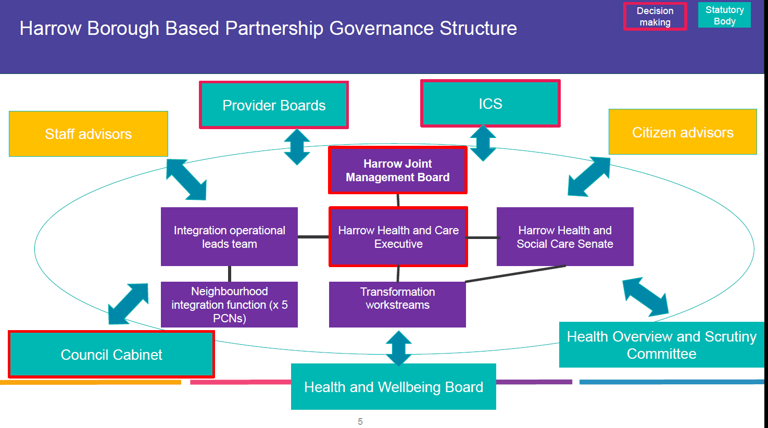**Governance, risk management in delivery and review**

Over 2021/22, the Harrow Borough Based Partnership has refined and strengthen its governance arrangements. The Harrow Borough Based Partnership Governance operates as a Joint Committee; a committee established between partner organisations, local authorities and statutory NHS providers. This Committee is the Harrow Borough Based Partnership Joint Management Board. Relevant statutory bodies have agreed to delegate defined decision-making functions to the joint committee in accordance with their respective schemes of delegation and a budget to support system transformation is overseen by this Committee. The Governance structure for the Borough Based Partnership is summarised in *figure 5*.Delivery of this plan will be overseen by the Harrow Health and Care Executive who are accountable for its delivery to the Harrow Joint Management Board. The Partnership maintain a risk register which is reported to each Joint Management Board meeting.

This plan will be reviewed on an annual basis.

Figure 5: Harrow Borough Based Partnership Governance Structure

1. **The Harrow Borough Based Partnership 2022/23 Delivery Plan**

**Draft in development – to be submitted with final version.**

**Appendix A - Key themes from our conversations with our communities**

|  |  |  |
| --- | --- | --- |
| **Themes** | **What we heard** | **What we did** |
| Disproportionate impact of the COVID-19 pandemic across Black communities | * Lack of Trust from Black Community Leaders * Assumption of what the black communities need as opposed to doing evidence-based research * The Need for Decisive Action | * Worked with VCS organisations to establish process for grant funding and support to local voluntary and community sector groups to enable collaborative research and engagement with Harrow’s Black and other minority ethnic communities. |
| Access to primary care | * Some people from other countries raised a dissatisfaction in what they felt was a telephone/digital first approach to GP consultations. They don’t feel confident with their English for e-consultations or speaking over the phone. * Some people from other countries don’t understand the health system and don’t know where to get this information in a simple manner. * Patients would like to know when they will be able to see their GPs face to face. Is there going to be any communications by letter to be informed about this? | * Provide clear information about interpreting services available in surgeries for new arrivals. * The team is intending to undertake curated work on health inequalities from May onwards, and so the ‘right care, right place’ messaging will be relevant in developing health literacy across Harrow. * Outreach took place in Edgware and Burnt Oak with small business owners within the Romanian community to discuss issues with accessing health care, GP accessibility and scepticism on vaccine. |
| Harrow Citizen Forum | * Access to primary care, medical appointments and elective procedures, were all raised as issues, by a number of attendees. * Attendees were mostly positive about the launch and remained keen to be involved in the development of the forum. A majority wanted more regular meetings than the mooted quarterly and were in favour of a mixed mode for maintaining the dialogue between meetings. | * Follow-up evaluation to add to the solicitation for feedback following the meeting. * Timetable and plan for continuing to iterate and develop the forum. * Review of internal engagement and equalities teamwork portfolios, to strengthen the emphasis among the team in community outreach and networking. * Agree the practical outputs for maintaining the conversation. |
| Vaccine/booster promotion | * I have previously contracted COVID so I do not need a vaccine * The need for a booster proved that the vaccines were inefficient in the first place * Confusion as to who was eligible and where to go for a vaccine. * Approximately 40% of those spoken with had not taken up the vaccine offer | * Vaccine/booster promotion through December 2021. * Romanian Community Outreach engaged in areas with high ‘white other’ population groups such as Edgware and Burnt Oak, where there is a sizeable cluster of Romanian small businesses. * Harrow BBP visited Harrow College’s South Harrow campus to speak with students about the ongoing vaccination campaign, approximately 140 students attending in all. Primarily students were aged 17-30, composed of mostly mature students learning English as a second language. * The team facilitated a series of positive conversations and provided advice and guidance in support of the vaccine. * The team estimated that 10-15% of these conversations with those reluctant resulted in a forward referral to a vaccine site. |

**Appendix B**

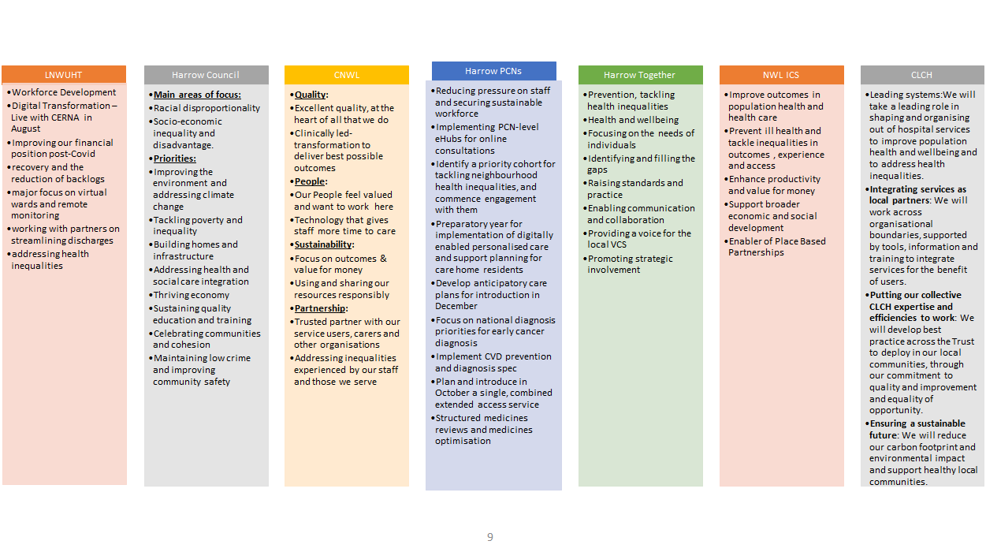**The priorities of Harrow Borough Based organisations 2022/23**

**Appendix C**

**Harrow outcome and performance measures**

**Diabetes: 9 Key Care Processes Achieved in Last 15 Months**



**Cancer Diagnosis and Treatment**

The graph below shows the backlog of NWL patients waiting > / = 62 days for treatment against the recovery plan.



**Cancer Screening in Harrow**

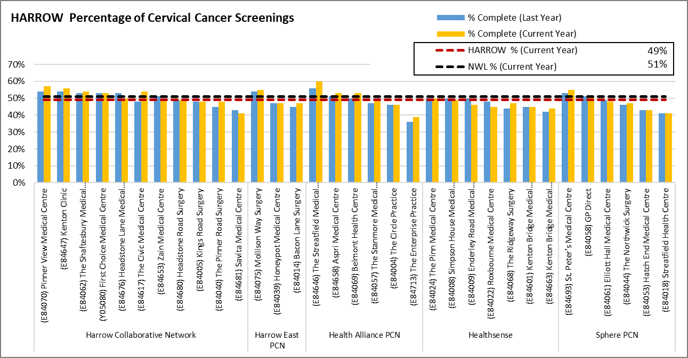

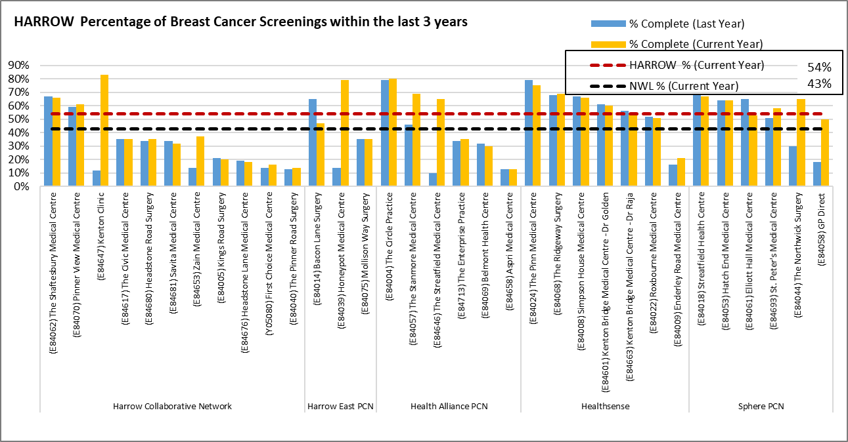

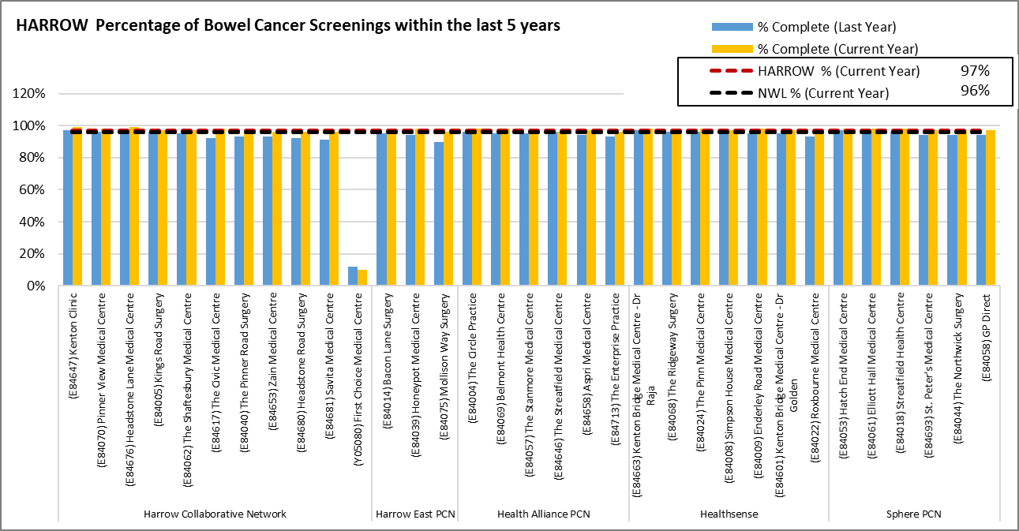

**Children Under Five Years Old with Tooth Decay**

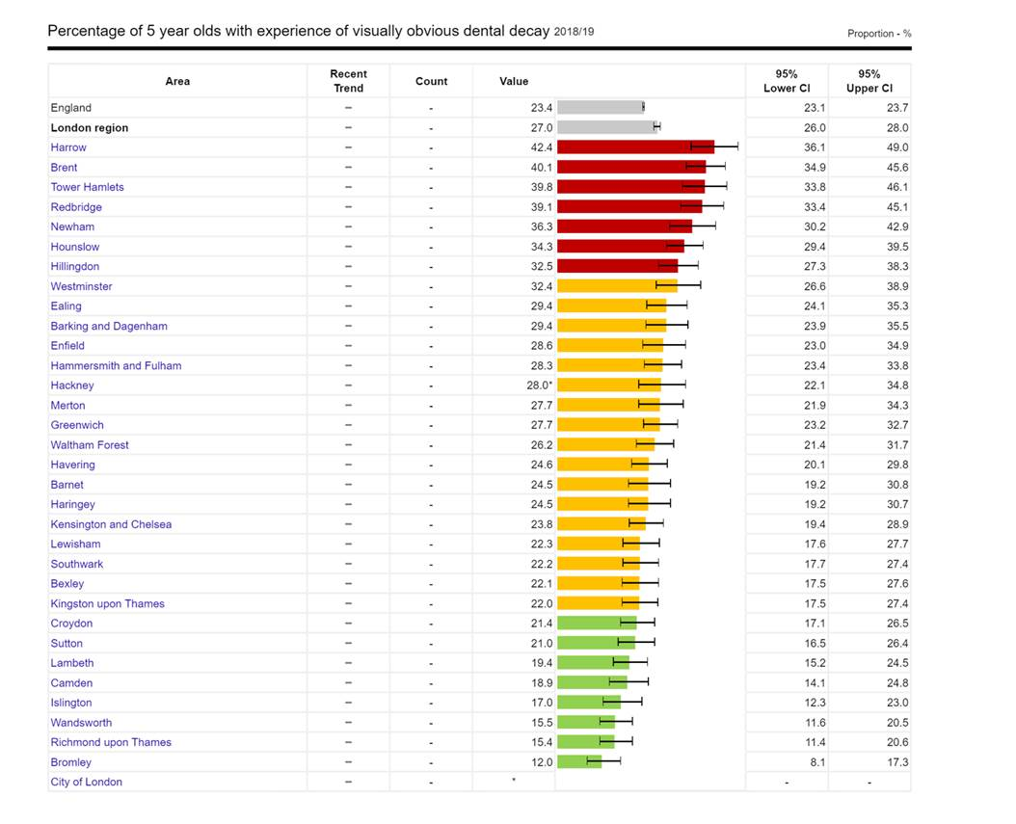

**Non-Elective Admissions**



**Appendix D**

**Harrow Borough Partnership Logic Model**